Information list
Great Altai Cup Rafting International competition

- General Information
From 7 to 16 June 2019 the International Tourist-Sports Festival «Great Altai. Russia-2019» (hereinafter «the Festival») is taking place in Altai Krai, Russian Federation.
From 8 to 12 June 2019 the Rafting International competition «Great Altai Cup» is being held during the Festival on the left bank of Peschanaya river 10 km upstream of Solonovka village, Smolensky District, Altai Krai.
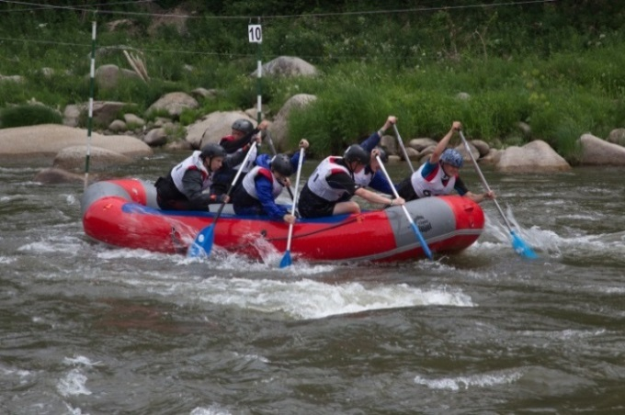 | The Competition is held according to IRF rules in order to promote and develop rafting in Russia and other countries, to improve skills of participants, to share experience and to strengthen business and social connections.
Organizers of the Competition:
- Russian Rafting Federation.
- Ministry of Sports of Altai Krai.
- Altai Krai Rafting Federation.
- Children and Youth Tourism Association.

- Programme
Date | Discipline
June 6th - 7th | Arrival of participants.
June 7th | Registration of participants, work of Credentials Committee, session of the Jury.
June 8th | The Opening ceremony of the Festival and the Rafting Competition.  Qualification rounds.
June 9th | Sprint - R6.
June 10th | Slalom - R6.
June 11th | Downriver - R6, Head-to-head - R6
June 12th | Award on the rafting competition.
June 12th-14th | Participation in the Festival program.
June 15th | The Closing ceremony of the Festival.
June 16th | Departure of participants from the Festival glade.
The Jury can change the Programme of the Competitions according to the meteorological and other conditions.

- Requirements for the participants of rafting competition
and terms of their eligibility
The individual-team Competitions among men's crews are held on Race levels: A - International: Raft-6. Цomen areallowed in men crews.
Vessels are provided by organizers (vessel is Timetrial Sport-6, monoclass).
Team roster: Raft-6: 7 members (1 reserve).
During the Competition the team can have the official representative who is not the member of the team. One member of the team can be substituted on the Competitions if there is a roster addition.
To enter the Competitions the following items shall be given to the Credentials Committee:
- application form of every member of the team, including the reserve and the representative, certified according to the IRF rules;
- identity document;
- record book;
- insurance certificate guaranteeing the compensation of medical and transport expenses caused by accidental injuries during the Competition from 8 to 15 June 2019.
At the day of handing in of an application athletes over the age of 16 are eligible to participate in the Competition, if they can swim.

- Other requirements
The advised team roster for the participation in the Festival stands at 10 people, including 1 team representative (coach), 1 referee (the deputy of the team representative), 6-8 athletes (including 1 woman minimum).
Organisation fee for the participants of the Festival is $100 and includes a registration fee of $30, an environmental fee, a merchandise kit, a pass tag, an access to the special team gear, accomodation, field meals and transit across Altai Krai.
Registration fee must be paid by 1 May 2019 by card in RUB according to payment day currency cost. The requisites are:
ACOO «ADIMTur»
Registered address: 656053, Severo-Zapadnaya St 119-1, Barnaul, Russian Federation
ITN 2221125210
IEC 222101001
PSRN 1072202001596
Bank: satellite office «Novosibirsky» of JSC Alfa Bank
Checking account 40703810023150000017
Corresponding account 30101810600000000774
The rest of fee is paid on registration site in RUB according to payment day currency cost.
The organizers provide transit from Barnaul airport/railway station to the Festival site on 6 and 7 June and back on 12 and 13 July for Contest participants and on 15 and 16 for the rest of Festival participants. Food facilities are organised along the road, the price of meal is about $5.
Big tent, tables and benches are provided by organizers during the campsite residency. Other gea r(tents, sleeping bags etc.) must be brought by participants. In order to rent the gear a form must be sent to organizers by 15 May 2019. | 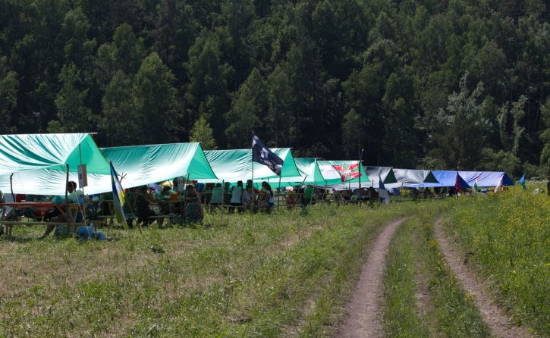

Gear advised for campsite residency
№ | Name | unit of measurement | amount | cost(in $)
 | Sleeping bag, mat(rented) | set | 1 | 5 per day
 | Two-man tent(rent) | unit | 1 | 5 per day
 | Cooking pot(at least 7l in volume) | unit | 2 | 10
 | Gas cooker and gas tanks for team use | set | 1 | 30
 | Personal set of dishes(metal/plastic) | set | 1 | 5

Every team must have common set of uniform with team emblems for participating in formal events and a country flag (at least 1,5m x 1m in size)

Advised list of personal gear
№ | Name | unit of measurement | amount
 | Sports outfit and shoes | set | 2
 | Warm outfit | unit | 1
 | Bad weather outfit | unit | 1
 | Headdress(cap/bandana) | unit | 1
 | Hygiene items(toothpaste, toothbrush, soap, toilet paper, wet wipes etc.) | set | 1
 | Raincoat | unit | 1
 | Flashlight | unit | 1
 | Anti-mite and anti-mosquito repellents | set | 1
 | Medikit, set | set | 1

Non-members of delegations (guests, viewers, tourists) pay for transfer, meals, accomodations and other expenses independently.

Contacts:
For further details, please, contact:

Alexey A. Shirokov,
Russian Rafting Federation President
Phone +7 (923) 402-84-83, E-Mail rusraft1@mail.ru

Anton V. Sergeev,
Festival Coordinator, Altai Krai Rafting Federation President
Phone +7 (903) 958-08-72, E-Mail: adimtur22@yandex.ru

Evgeniya A. Silyutina,
Festival Secretary
Phone +7 (903) 911-62-07, E-Mail: vea1976@mail.ru.

